Food Delivery Analytics Power BI

Project Overview:
This project analyse food delivery operations using Power BI. The dashboard provides insights into revenue, orders, customer satisfaction, delivery performance, and marketing campaign effectiveness. Power Query was used for ETL, DAX for KPI calculations, and a Star Schema was designed for efficient reporting.

Business Problem:
- Analyse food delivery business performance.
- Track revenue and order trends.
- Measure delivery performance.
- Evaluate customer satisfaction.
- Measure campaign effectiveness.

Dataset Information:
Insert a table like this:
Table | Description
fact_orders | Order details
fact_order_items | Ordered items
fact_ratings | Customer ratings
dim_customer | Customer information
dim_city | City information
dim_restaurant | Restaurant details
dim_rider | Rider details
dim_date | Date dimension
dim_payment_method | Payment information
dim_marketing_campaign | Campaign details
bridge_order_campaign | Bridge table

Power Query (ETL):
- Imported folder data.
- Combined monthly files.
- Promoted headers.
- Changed data types.
- Removed unnecessary columns.
- Loaded dimension tables.

Data Model:
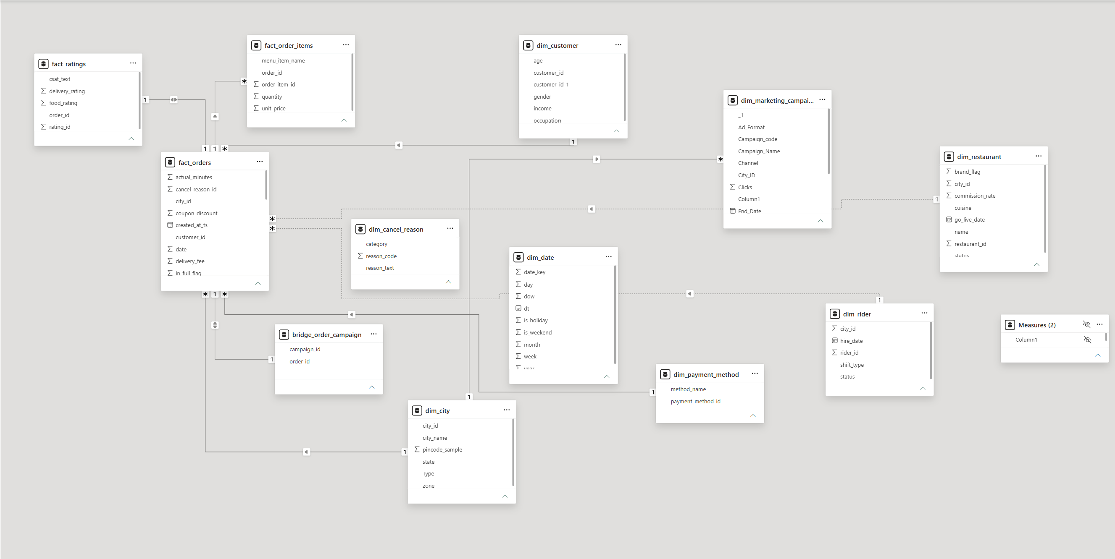

Executive Dashboard:
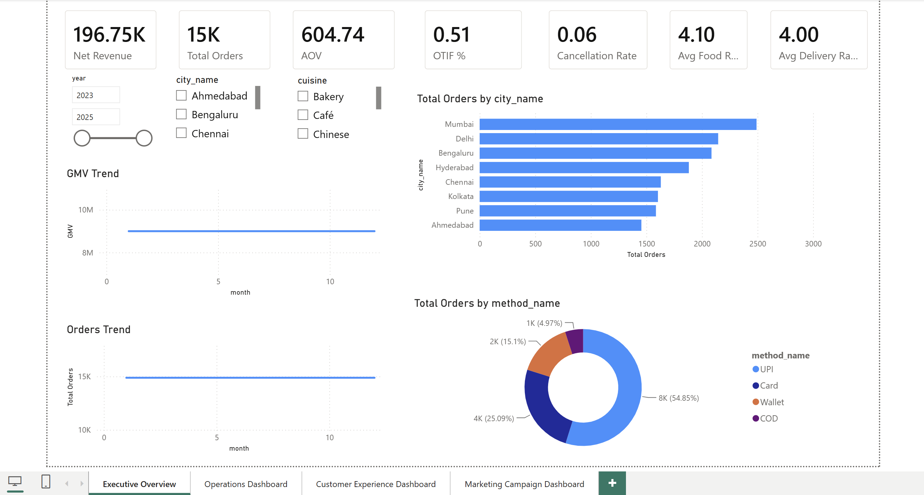

Operations Dashboard:
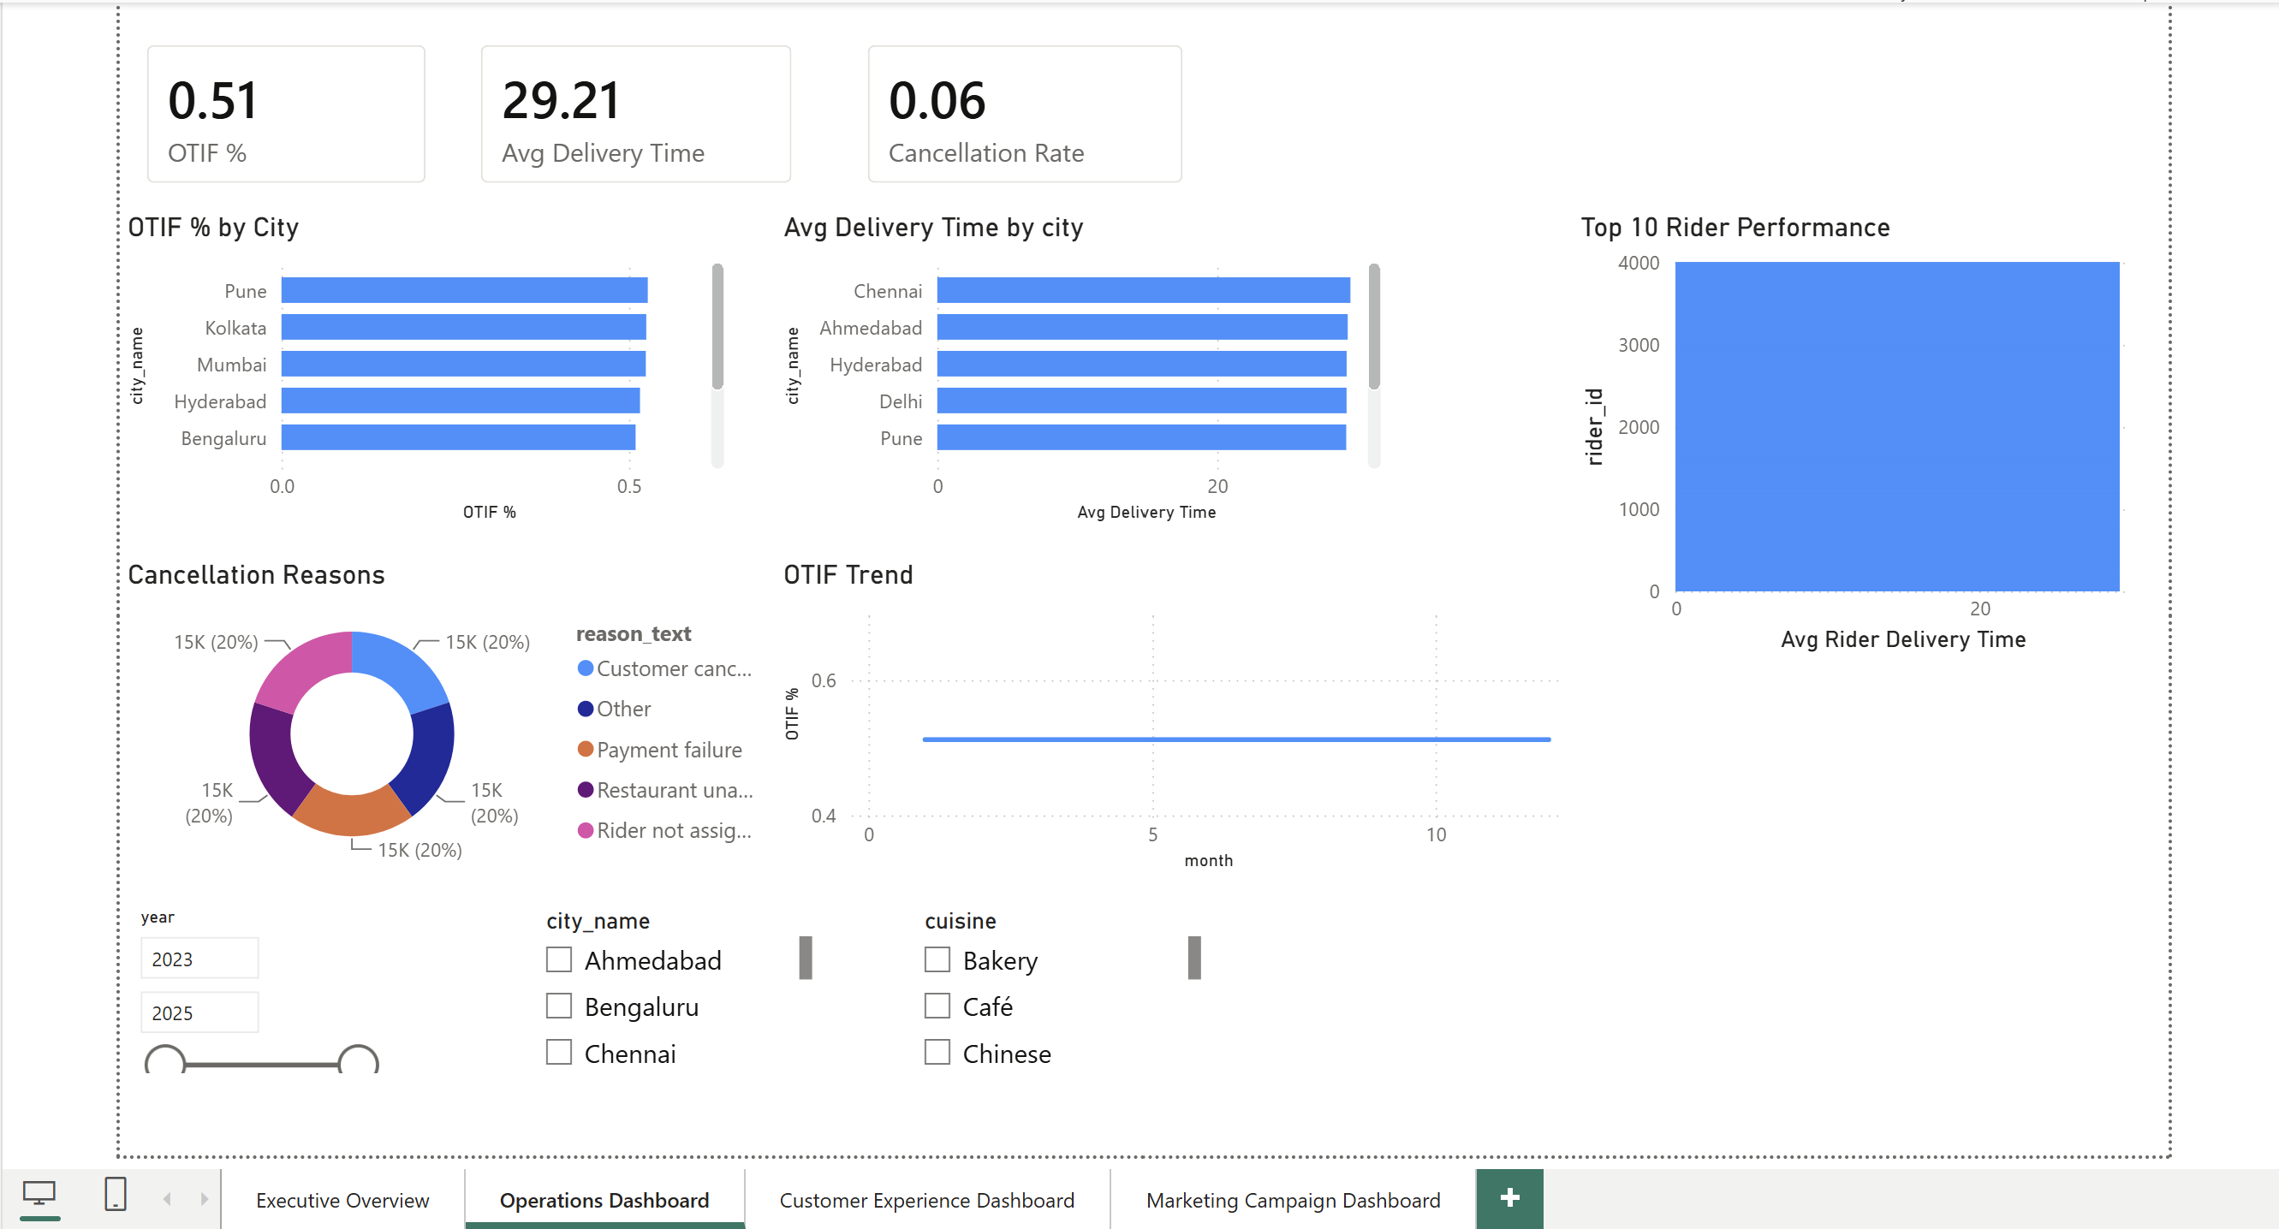

Customer Experience Dashboard:
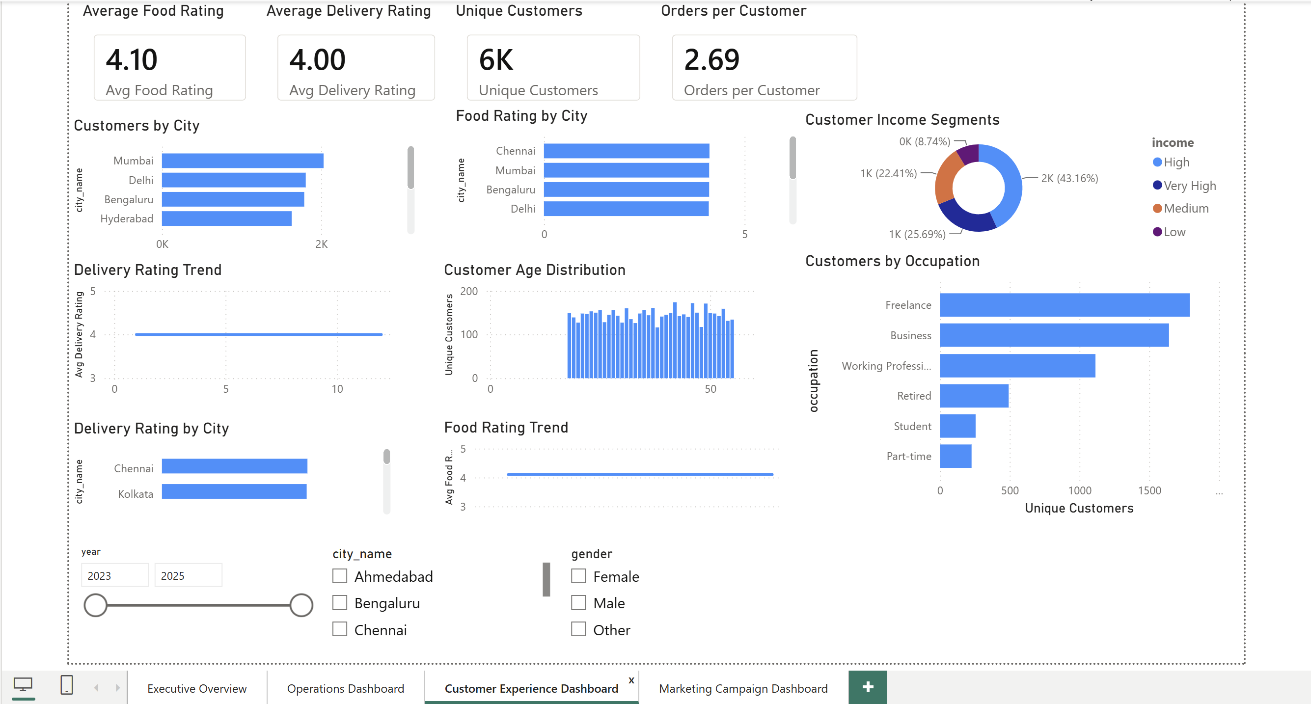

Marketing Dashboard:
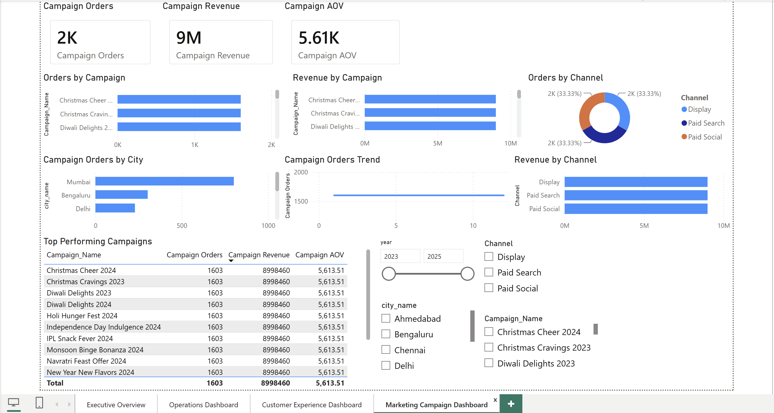

Key Insights:
- Mumbai generated the highest number of orders.
- UPI was the most used payment method.
- Display campaigns generated the highest revenue.
- Average Food Rating was 4.10.
- OTIF performance was approximately 51%.

